Stem cell discovery: Australian scientists make significant find while studying zebrafish
Mandie Sami
Updated Thu at 6:47pmThu 14 Aug 2014, 6:47pm
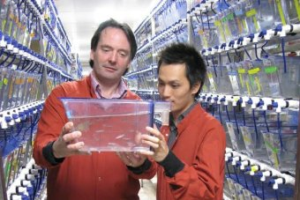PHOTO: Professor Peter Currie and Phong Nguyen in the 7,000-tank fish facility. (Supplied: Monash University)

Australian scientists studying zebrafish have stumbled upon what they say is one of the most significant discoveries in stem cell research.
In research published on Thursday in the journal Nature, the Monash University scientists revealed that they uncovered how one of the most important stem cells in blood and bone marrow, the haematopoietic stem cell (HSC), is formed.
Professor Peter Currie, from Monash University's Australian Regenerative Medicine Institute, said the discovery brought researchers closer to growing HSCs in a lab.
"HSCs are the basis of bone marrow transplantations as a therapy, so when a leukaemia patient receives bone marrow, it's really these HSCs that do the heavy lifting," Professor Currie said.
"So when clinicians do bone marrow transplants, they need to find a matching donor recipients and we know that's a hit-or-miss procedure.
"So for many years people have been trying to make HSCs in the dish, and they've had very little success in doing this."
Professor Currie, who led the study, said the discovery brought scientists much closer to achieving that aim.
"It's the discovery of a completely new cell type that basically is required to give instructions to the HSC to make it become what it needs to become," he said.
"It means we now understand how HSC form in the body better, we can use that information to try to grow these cells in the dish and we hope that will lead to better treatment for people with leukaemia and blood disorders."

Zebrafish genetically close to humans
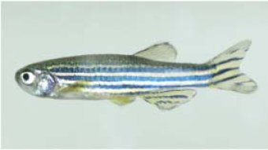PHOTO: 70 per cent of human genes are found in zebrafish.(Supplied: Monash University)
Professor Currie said he specialises in muscle stem cell biology and accidentally came across the discovery while studying muscle stem cells in zebrafish.
"It was such a serendipitous finding, because I wasn't looking for it, I was looking for something else, it's unclear that this would've been discovered any other way," he said.
Professor Currie said zebrafish were the fastest-growing model for biomedical researchers because they were genetically similar to humans.
"The genes that separate us from fish are very few indeed and in fact you could basically consider us modified fish," he said.
"It's basically the way the genes are switched on and off that make us different between a fish and a human being.
"So we can use the fish as a model because all the genes that are in there, are in us."
He said the other advantage of zebrafish was that they were completely transparent as larvae.
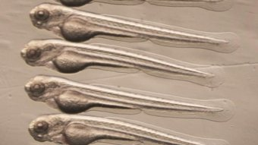PHOTO: Zebrafish larvae are used by scientists because they are transparent. (Supplied: Monash University)
"Basically it is because they're completely optically clear, we can see every single formed cell on the body, every organ form, the heart beating, blood coursing," he said.
He said that is how his team were able to discover how the HSCs formed.
"We can see the cells glowing under the microscope so we can actually make home movies if you like, of the cells as they form in the embryo and by playing these movies back and looking at them, we get a very good understanding about how these particular cell populations form in the embryo," he said.
"We hope that that will lead to better treatments for people with leukaemia and blood disorders."

'Accidental' discovery of how blood cells form
Professor John Rasko, who specialises in haematology at the University of Sydney, said the the discovery was exciting.
"Isn't it wonderful to reflect that these researchers were first trying to understand how muscles are produced but now have shed extraordinary light on how blood is produced?" Professor Rasko said.
If we don't contribute to this kind of research, then we won't be able to see improvements in the future for everybody suffering from these serious diseases, leukaemia, lymphoma, myeloma and a series of different solid cancers.
Professor John Rasko
"What a wonderful example of serendipity where studying muscles has shed extraordinary new light on blood cell formation."
Professor Rasko said the research brought the field one step closer to growing HSCs in a lab.
"This provides us with one new piece of the puzzle that might one day allow us to learn how to grow blood-forming stem cells outside of the body which is currently impossible," he said.
"It's a small piece of the puzzle but it's a very, very important piece because understanding how blood is formed in the embryo sheds light on the mechanisms that are essential to understand if one day we are able to do this in the laboratory."
Professor Rasko said the discovery was "a great example of fantastic Australian research".
"If we don't contribute to this kind of research, then we won't be able to see improvements in the future for everybody suffering from these serious diseases, leukaemia, lymphoma, myeloma and a series of different solid cancers," he said.

